**INTRODUCTION**

**1. INTRODUCTION**

**1.1 About the project:**

The project titled by “**VIDHYA**” is the part of sixth semester. Vidhya is an educational website. It is helpful for students for better education. Students can attend online classes, can watch video tutorials, attend mock tests, can download previous question papers and question banks etc.

While there are many advantages of such websites, we also need to be aware of the negatives. Students need to be guided properly. Without proper guidance, students may find resources and content that are not reliable or do not align with the direction of the teaching in class. Some websites are huge and offer a massive variety of games and resources. Students may be easily distracted on such websites and end up spending time on activities that are either below their level or do not complement or add to the classroom teaching. Unrestricted access and freedom on the internet can be dangerous, especially for younger students.

**1.2 Objectives of the System**

The main objective of the project is to make the whole working academy smoothly. Basically, the whole of the academy is as manually. But this may cause some difficulties. Through this project the daily routine and duties can be monitored by the admin and also by the manager of the academy. Examiner can psot exam link and time table daily. There are some duties for examiner, manager, teacher. So this will help the whole working of the academy smooth and digitally accessible to everyone. Here also academy provide course for the students. The user can understand all about the website simply.

**SYSTEM STUDY AND ANALYS**

1. **SYSTEM STUDY AND ANALYSIS**

System analysis is a detailed study of various operation performed by a system and the relationship within and outside of the system. One aspect of analysis is defining the boundaries of a system and determining whether or not a candidate system should consider other related system. Analysis begins when a user begins a study of the programs using an existing system. System analysis is an application of system approach to the problemsolving using computers.

During analysis data is collected on the various files, decision points and transactions handled by the present systems. This means that to do system works, one is to understand the system concepts and how the organizations operate as a system and the design appropriate computer based system and that will make the organization requirements. It is actually customized approach to the use of computer problem solving.

**3.1 Existing Systems**

The existing system is considered as manual paper processing system. All works done with a lot of paper work involved. Paper work is one of the old fashioned methods. There are many websites and applications for education.

**3.1.1 Drawbacks of Existing System**

* It is inconvenient and time consuming
* It is difficult to manage
* It is manual system

**3.2 Proposed System**

Education System is based on the concept of helping students for their better studies. Before stepping into the main menu a user has to pass through a login system to get access, then the user can manage criminal records by adding, updating, removing, viewing and searching for details. This system is developed for the purpose of making management more secure, systematic and efficient .Vidhya consist of 5 modules which are Admin, Examiner, Teacher, Manager and Student.

The objectives of the Education System are: To develop a systematic inventory management of Eduation System. To provide a good studies.The scope of website consist of mock tests, online classes,video tutorials,download datas.

**3.2.1 Functional Requirements**

* Admin can login and register the manager, teacher and examiner.
* Admin can control and see the activities of all.
* Staff can login only using their username and password and they can store data.

**3.2.2 Advantages of Proposed System**

* Security Provided
* User friendly
* The system makes the overall project management much easier and flexible

**4.1Feasibility Analysis**

Whatever we think need not be feasible. It is wise to think about the feasibility of any problem we undertake. Feasibility is the study of impact, which happens in the organization by the development of a system. The impact can be either positive or negative. When the positives nominate the negatives, then the system is considered feasible. Here the feasibility study can be performed in two ways such as technical feasibility and Economical Feasibility

* **Technical Feasibility:**

We can strongly say that it is technically feasible, since there will not be much difficulty in getting already required resources for the development and maintaining the system as well. All the resources needed for the development of the software as well as the maintenance of the same is available in the organization here we are utilizing the resources which are available.

Technical feasibility is all about the hardware and software facilities in ‘VIDHYA’ is an application software, so it uses only normal hardware devices monitor, keyboard, mouse etc So, the ‘VIDHYA’ is technically feasible.

* **Economic Feasibility:**

Development of this application is highly economically feasible. The organization needed not spend much money for the development of the system already available. The only thing is to be done is making an environment for the development with an effective supervision. If we are doing so, we can attain the maximum usability of the corresponding resources. Even after the development, the organization will not be in a condition to invest more in the organization Therefore, the system is economically feasible.

**4.3 Project Planning:**

As per the initial planning of project has completed within 2 months. For the system study and technical assistance, I met Smt. Sreejitha our project guide. According to the plan, hardware requirements of this project are monitor, keyboard, mouse, Intel CORE processor, 2GB RAM, AND 160GB hard disk etc. The software used were NetBeans IDE, as development environment for Python Django, MYSQL as server. The deadline of project is March 1st week.

**4.4 Software requirement specification (SRS)**

1. Introduction Computer and information technology has a major influence on the society. And the society is becoming more and more dependent on technology. Going on is an area of simplifying almost all complicated works using computer. The last few years witnessed a tremendous increase in the capabilities and use of computers. Manual processing makes the process slow and the other problems such as inconsistency and ambiguity on operations. The proposed system intends user-friendly operations which may resolve ambiguity. By considering all this factors, the application produced, which performs the social services simply and effectively. 1.1 At the beginning admin of this application should approve each profile of staff. Then only they login into their site. Admin can view the daily works. They can communicate through the notification section provided in the each profile. Examiner can post the exam links and students can attend the exam. Manager will give the updates about their company and add job offers. Students can view job offers and can apply too the jobs they wanted according top job offers. Teacher will add google meet link for online video classes. Students can attend the online class through that link. Students can view tutorial classes which the teachers added. Admin will register workers. Admin can view all registrations.

**Definitions, Acronyms and Abbreviations**

DB – Database` IDE – Integrated Development Environment

1.4 References The technical assistance for the project is provided by Ms. STEPHY, WEB Developer of FAB STUDIOZ 2.

**2 User Section Software VIDHYA contains 5 main modules based on the services provided. That are,**

• Admin Login

• Manager Login

• Examiner Login

• Students Login

• Teacher Login

**2.1.3 Hardware interface**

Processor : Intel Pentium

RAM : 4GB

HDD : 160 GB or Higher

System bus : 64 BIT

Monitor : Hp

monitor Keyboard : Logitech (104keys)

Mouse : Logitech

**2.1.4 Software interface**

Platform : Windows 10

Language : Python

Backend : SQL

Alchemy Browser :Chrome

**2.1.5 Communication interface**

The user can communicate with the system through Graphical User Interface

**SYSTEM DESIGN**

**5. SYSTEM DESIGN**

**5.1 Fundamental Design Concepts**

Design is the first step in the development phase for any engineered product or system. Design is a creative process; a good design is the key to effective system. The term “Design” is defined as “The process of applying various techniques and principles for the purpose of defining a device, a process or a system in sufficient detail to permit its physical realization”. It may be defined as the process of applying various techniques and principles for the purpose of defining a device, a process or a system in sufficient detail to permit its physical realization. Software design sits at the technical kernel of the software engineering process and is applied regardless of the development paradigm that is used.

From a project management point of view, software design is conducted in two steps. Preliminary design is concerned with the transformation of requirements into data and software architecture. Detail design focuses in on refinement to the architectural representation that leads to detail algorithm data structure and representation of software.

In system design high-end decisions are taken regarding the basic system architecture, platform s and tools to be used the system design transforms a logical representation of what a given system is required to be in the physical specification. Designs start with the system requirement specification and convert it to physical reality during the development. Important design factors such as reliability response time, through put of the system maintain ability, expand ability etc should be taken into account.

**5.1.1 Input Design:**

In the input design, user-oriented inputs are converted into a computer based system format. The major approach to input design is the menu and prompt design. In each alternative, the user’s options are predefined. The data flow diagram indicates logical data flow, data stores, source and destination. Input data are collected and organized into a group of similar data. Once identified inputs are selected for processing.

In this software, importance is given to develop Graphical User Interface (GUI), which is an important factor in developing efficient and user-friendly software. For inputting user data, alternative forms are designed. User can also select desired options from the menu, which provides all possible facilities. Also, the important inputs formats is designed in such a way that accidental errors are avoided. The user has to input only just minimum data required, which also helps in avoiding the errors that the users may make. Accurate designing of the input format is very important in developing efficient software. The goal or inputs design is to make entry as easy, logical and free from errors

**Input Forms are:**

The different forms used in software are:-

* Login form
* User registration form
* Data information form

**5.1.2 Output Design:**

In output design, the emphasis is on producing a hard copy of the information requested or displayed the output on CRT screen in predefined format. Two of most output medias today are printers and the screen. Most users now access their reports from a hard copy or screen display. Computers output is the most important and direct source of information to the user, efficient, logical, output design should improve the system relations with the user and the help in decision-making.

As the outputs are the most important source of information to the user, better design should improve the system's relation and also should help in decision-making. The output device's capability, print capability, response time requirements etc should also be considered form design elaborates the way output is presented and layout available for capturing information. It's very helpful to produce the clear, accurate and speedy information for end users.

**Output Forms are:**

* View page.
* View Project
* View details of data

**See Appendix A for Screen Shots**

`

**5.2 DATABASE DESIGN**

Database design is organized as a standard of management information system and is available virtually for every computer system. The general theme behind a database is to integrate all the information. A database is an integrated collection of data and provides centralized access to the data. A database is a collection of inter-related data stored with minimum redundancy to serve many users quickly and efficiently. The general objective of data base design is to make the data access easy, inexpensive and flexible to the user. A good data base design does the following:

1. Provides minimum search times when locating specific records.

2. Stores the data in the most efficient manner possible to keep the database from

growing large.

3. Make data updates as easy as possible.

4. Is flexible enough to allow inclusion of new functions required of program.

The DBMS is responsible for enforcing the database structure, including

1. Maintaining the relationships between data in the database

2. Ensuring that data is stored connately, and that the rules defining thus

Relationships are not violated

3.Recovering all data to point of known constancy in case of system.

**5.2.1 Overall Description**

The project titled VIDHYA facilitates the users to store data. Also only the registered users can enter in to the process and also the registration is done by the admin and so it gives more security than the old system. The users can view projects. There is more security and save the valuable time.

1. **Product Perspective**

The project titled VIDHYA is a software application. Here we are computerizing the standards

1. **System Interface**

The user calcommate with the system through the Grapid Lier Interface which is the active

1. **User Section**

Software Vidhyacontains 5 main modules based on the services provided. That me

* Admin
* Manager
* Examiner
* Teacher
* Student

**Admin login module:**

In proposed system there is separate login for Admin They have certain special credentials for accessing the system. Also they should provide username and password. They can directly enter to their own home page and can add users.

**Manager:**

Citizen can enter in to their own home page, can add job offers, courses, update, can edit the details of the already uploaded project, can group by the projects from the system..

**Examiner:**

Examiner can enter in to their own home page, can upload exam details like exam timetable, link, question paper.

**Teacher:**

Teacher can enter in to their own home page, can upload previous question paper, question banks, assignments etc.

1. **Communication interface**

The user can communicate with the system through Graphical User

Interface.

1. **Memory constraints**

15 Intel Pentium processor or higher with a minimum of 8GB RAM and

160 GB of hard disk space will be required so that the software performs its

functions in an optimum manner.

1. **Operations**

The operations of general user are limited, but the registered users can view the works and import works.

1. **Adaptation requirements**

The user must careful when they provide personal details such as

username, password, email id etc.

**5.3 NORMALIZATION**

**5.3.1 DATA NORMALIZATION**

Normalization is the term obtained from the Latin word “NORMA” which means that square used by the carpenter. Normalization is the process of simplifying the relationship between data elements in a record. Through normalization a collection of data in a record structure is replaced by successive record structures that are simpler and can be managed efficiently. While designing the data base, we have to implement the concept of normalization to avoid redundancy in database.

Normalization is being carried out for four reasons:

* To structure the data so that any pertinent relationship between entities can be represented.
* To permit simple retrieval of data in response to query and reports required.
* To simplify data maintenance procedure such as insertion, deletion and updating.
* To reduce the need to be structured or recognized data with new application requirements arise.

The major normalization strategies:

* First Normal Form
* Second Normal Form
* Third Normal Form
* Boyce/Code Normal Form (BNCF)

**First Normal Form**

First Normal Form is achieved when all repeating groups in a record are removed, so that record is of fixed length. A repeating group, reoccurrence of a data item or group of data item within a record indicates another relation.

**Second Normal Form**

It is achieved when a recovered is in first normal form and each item in the record is functionally dependency. A data item is functionally dependent of its value is uniquely associated with a specific item. To achieve second normal form every column in a table that is not dependent on the primary key of the record should be removed and used to form a separate relation

Secure Vidhya system uses a database in second normalized form since all non-key attributes of each table is depend on the key attribute of that table. Database in the web server is managed by MySQL Server. The database contains four tables and the details of the tables are specified in the appendix B.

By normalizing the database into 2NF we could remove data redundancy in the tables Normalization also improved the performance of the application since the complexity of handling a normalized database from the front end always less. Integrity constraints are implemented in the database by specifying the primary key in tables. Also validations are performed at the front end code.

**See Appendix B for Table design**

**SYSTEM TESTING**

**6.SYSTEM TESTING**

Testing is a process of executing a program with the intention of finding error. If testing is conducted successfully, it uncovers error in software. Also testing demonstrates the software functions appear to be working according to the specification that behavioral and performance requirements appear to have been met.

**6.1 Testing Objectives:**

* Good tests can one that has a high probability of finding a yet undiscovered error.
* A successful test is one that uncovers a yet undiscovered error.

**6.2 Type of System testing:**

* **UNIT TESTING**

Unit testing focuses verification effort in the smallest unit of software design, the software component or module. The unit test is box oriented, and the step can be performed in parallel for multiple components. We tested the module interface to ensure that information properly flows into and out of program unit under test. The local data structure was examined to ensure that data store temporarily maintained its integrity during all steps. All independent paths through the control structure exercise to ensure that all statements in a module have been exercised at least once.

**LOGIN**

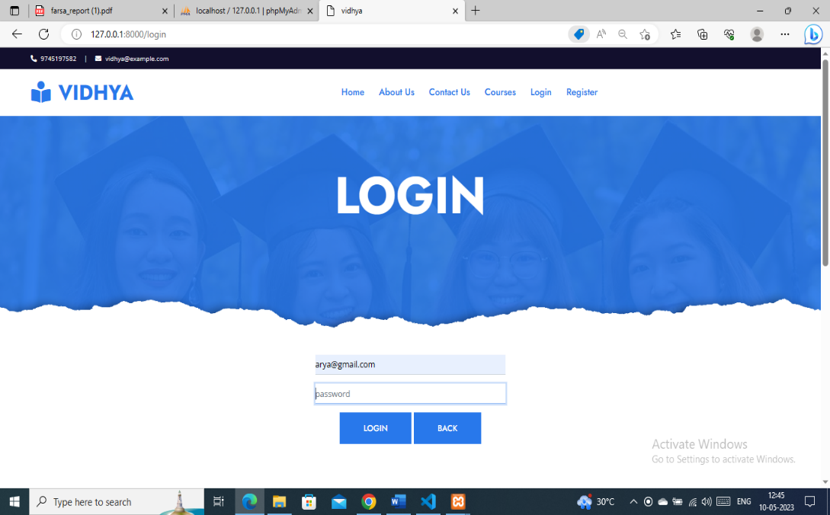

* **INTEGRATION TESTING**

Integration testing is a systematic technique for constructing the program structure while at the same time conducting test to uncover errors associated with interfaces. Integration testing is a systematic approach for constructing the program structure, while at the same time constructing test to uncover errors associated within the interface. The objective is to take unit tested modules and builds program structure. All the modules are combined and tested as a whole.

**STUDENT HOME PAGE**

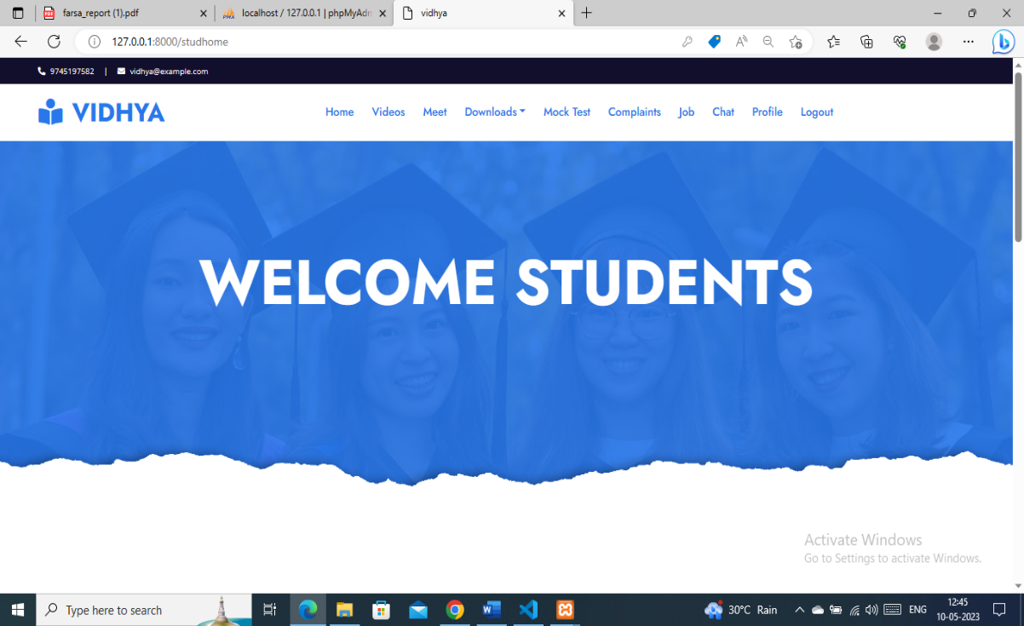

**TEACHER HOME PAGE**

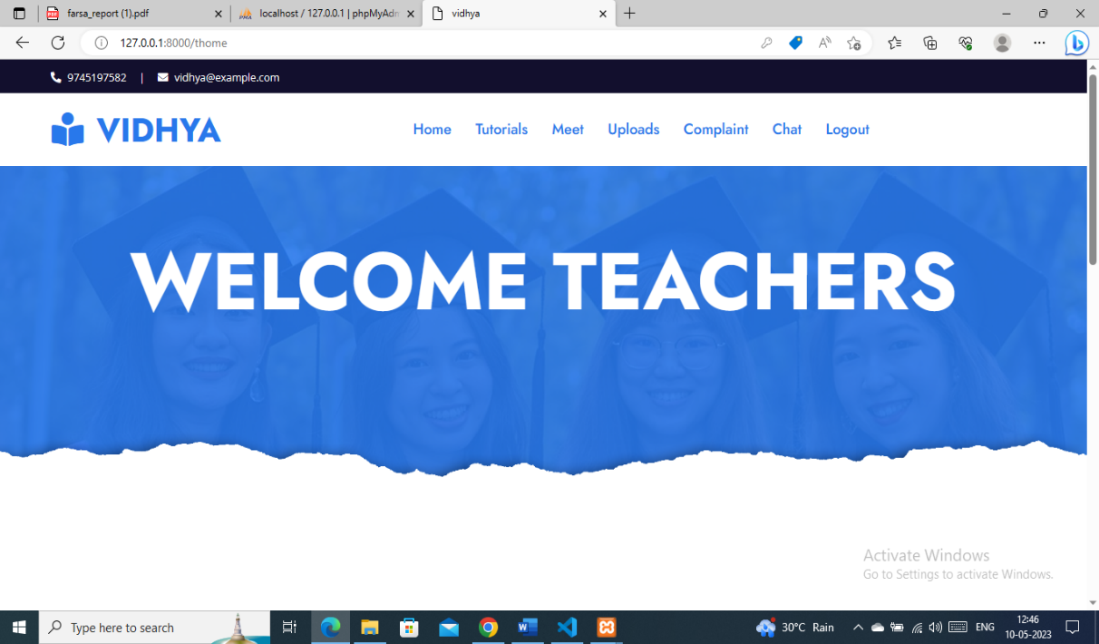

**EXAMINER HOMEPAGE**

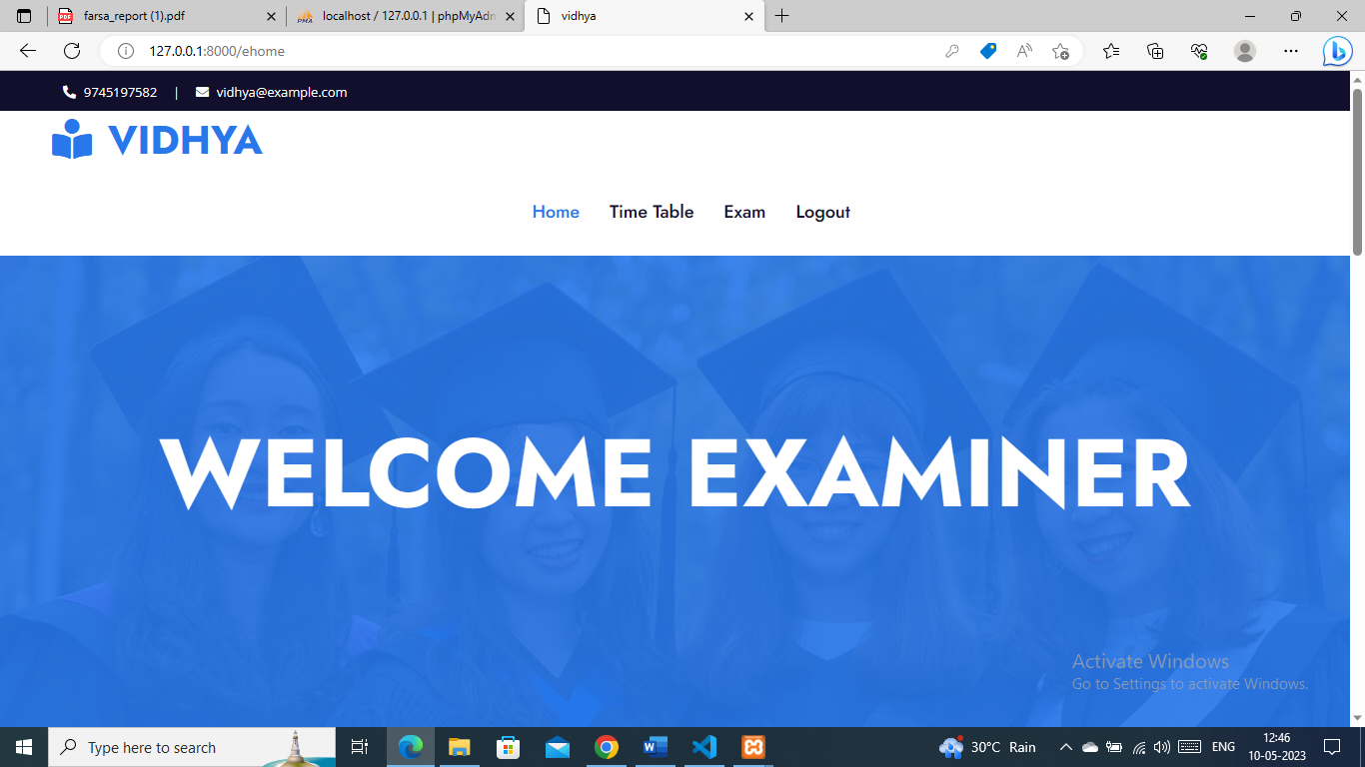

MANAGER HOMEPAGE

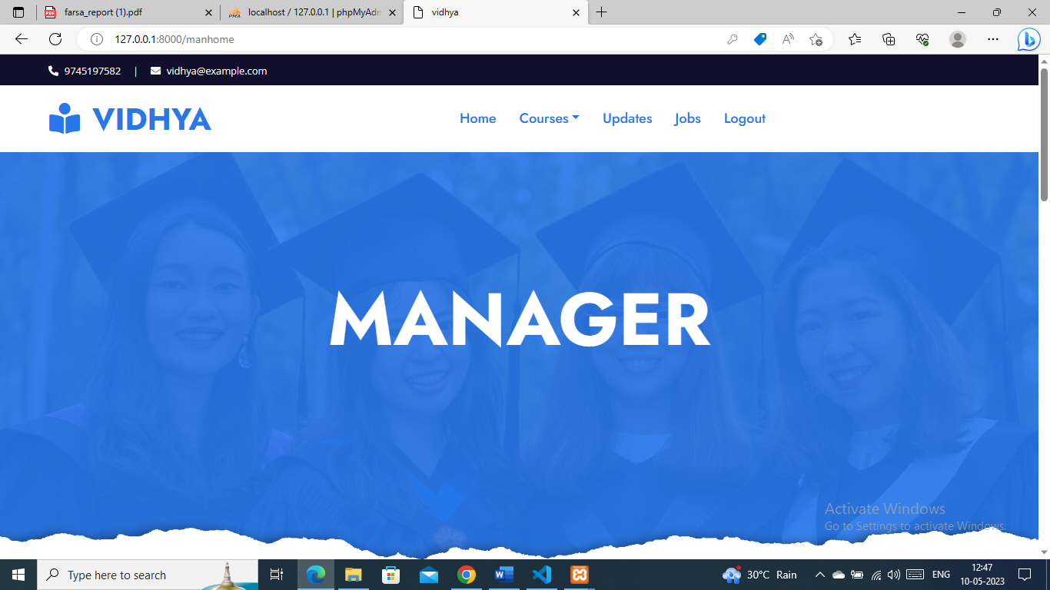

* **VALIDATION TESTING**

A quality assurance process carried out before the software is ready for release is known as validation testing. Its goals are to validate and be confident about the software product or system, that it fulfills the requirements given by the customer. The acceptance of the software from the end customer is also its part. Validation succeeds when the software function in a manner that can be reasonably expected by the customer.

During validation tests, we designed both plan and procedures to ensure that all functional requirements were satisfied, all performance required were attained, documentation was corrected and human engineered requirements were met.

**LOGIN VALIDATION TESTING**



* **BOUNDARY VALUE ANALYSIS**

Since a greater number of errors tend to occur at boundaries than in the center, boundary value analysis is conducted. It leads to selection of tests cause that exercises boundary values.

It makes use of the fact that the inputs and outputs of the components under test can be partitioned into ordered sets with identifiable boundaries. Values in the same set will be treated in the same way. Test values are chosen that are just inside, on and just outside the boundaries.

* **BETA TESTING**

In software development, a beta test is the second phase of software testing in which a sampling of the intended audience tries the product out. Beta is the second letter of the Greek alphabet. Originally, the term alpha-testment the first phrase of testing in a software development process. Beta testing also known as user testing takes place at the end users site by the end-users to validate the usability, functionality, and reliability testing.

**SYSTEM MAINTENANCE**

**AND**

**SYSTEM IMPLEMENTATION**

**7. SYSTEM MAINTENANCE AND SYSTEM IMPLEMENTATION**

**7.1 SYSTEM MAINTENANCE**

Software maintenance is the process of modifying a software system of component after its delivery in order to correct faults, improve the performance and the other attributes, or to adapt to the changed environment Maintenance covers a wide range of activities including correcting the coding and design errors, updating the documentation and test data, and upgrading the user support. There is an aging process that calls for periodic maintenance of hardware and software. Maintenance is always necessary to keep the software usable and useful. Hardware also requires periodic maintenance activities can be classified into

* Corrective Maintenance
* Perceptive Maintenance
* Adaptive Maintenance

Corrective maintenance removes software faults. Perceptive maintenance improves the system without changing its functionality. The objective of perceptive maintenance should be to prevent failures and optimize the software. Adaptive maintenance modifies the software to keep it up-to-date with its operative environment.

**7.2 SECURITY MEASURES**

Any software developed should be secured and protected against possible hazards. Security measures are provided to prevent unauthorized access of the database from various levels.

Software is heart of an organization’s computer operation. Therefore, it is essential that software function correctly and be protected from corruption. Closely related to software support is configured management-the process of keeping track of changes to the system and if needed, approving them. Configuration management normally addresses hardware, software, networking and other changes; it can be formal or informal. The primary security goal of configuration management is to ensuring that changes to the system do not unintentionally or unknowingly diminish security. A second security goal of configuration management is to ensuring that changes to the system do not unintentionally or unknowingly diminish security. A second security goal of configuration management is ensuring that changes to the system are reflected in other documentation, such as contingency plan. If the change is major, it may be necessary to reanalyze some or all of the security of the system.

**Backups**

Usually support and operation personnel backup software and data. This function is critical to contingency planning. Frequency of backups will depend on how often data changes and how important those changes are.

**SYSTEM IMPLEMENTATION**

**8.1 SYSTEM IMPLEMENTATION:**

Implementation includes all those activities that take place to convert from the old system to the new. The old system consists of manual operations, which is operated in a very different manner from the proposed new system. A proper implementation is essential so provide a reliable system to meet the requirements of the organizations. An improper installation may affect the success of the computerized system.

**Implementation Method**

There are several methods for handling the implementation and the consequent conversion from the old to the new computerized system. The most secure method for conversion from the old system to the new system is to run the old and new system in parallel. In this approach, a person may operate in the manual older processing system as well as start operating the new computerized system. This method offers high security, because even if there is a flow in the computerized system, we can depend upon the manual system. However, the cost for maintaining two systems in parallel is very high. This outweighs its benefits

Another commonly method is a direct cut over from the existing manual system to the computerized system. The change may be within a week or within a day. There are no parallel activities. However, there is no remedy in case of a problem. This strategy requires careful planning.

**Implementation Plan**

The implementation plan includes a description of all the activities that must occur to implement the new system and to put into operation. It identifies the personnel responsible for the activities and prepares a time chart for implementing the system. The implementation plan consists of the following steps:

► List all files required for implementation

► Identify all data required to build new files during the implementation. List all new documents and procedures that go into the new system.

► Project is implemented and hence found that it satisfies all the objectives of the system

Implementation is the process of converting a new system in to an operational one. It is a key stage in achieving a successful new system it involves a lot of upheaval in the user department. It must therefore be carefully planned and controlled. Implementation is mainly concerned with the following,

* User training
* Documentation

**8.2 USER TRAINING:**

After the system is implemented carefully, training of the user is one of the important subtasks of developer.

**8.3 DOCUMENTATION:**

The whole system is documented and presented in a readable manner. The documentation is useful for future use.

**CONCLUSION**

**9. CONCLUSION**

VIDHYA system is highly secure solution that enables the activities of data standardization. It helps to make the process easier it facilitates the registered users to add complaints. It provides online classes, video tutorials, mock tests, etc.

It was completed successfully within the time span allotted. I am very satisfied to get this opportunity to do this project. This project is developed by using Python Django As it is very flexible with user friendly screens, the user can use without inconvenience. This provides a better system and avoids existing system problems. It also satisfies present requirements. All the knowledge I gained is full applied in the design of the mentioned system application package is developer. All the suggestions forwarded in the software proposal have been completed. This system is developed in such a way that the modules developed in the future can be linked easily to the system, without affecting the existing system, since it provides a hierarchical structure.

Top-down programming approach has been adopted while developing the project, each task is divided into separate modules. Hence modification and enhancement can be easily made without affecting any other part of the program. The performance of the system is provided efficiently. The system was tested with all possible sample data and was found to have an affective planning of the functions or process with a high degree of accuracy and user friendliness.

ARYA VIJAYAN

**SCOPE FOR FUTURE ENHANCEMENT**

**9. SCOPE FOR FUTURE ENHANCEMENT**

This application is developed to design in such a way that any further enhancement can be done with ease. The application proves better extensibility and flexibility for future enhancements. Any further requirement application is possible with the features guaranteed. The design of this software is in such a way that the addition of any new module if necessary is possible without affecting the integrity of the present system.

The system is capable to accommodate future use also. We can modify or enhance the system with the same platform. The change in the system do not blocks the present system. The system is implemented with higher degree of accuracy and user friendliness Role based Access Control (RBAC) or user collaboration is not planned as a part of this work. It will be enhanced in future

**BIBLIOGRAPHY**

**10.BIBLIOGRAPHY**

Websites

* <https://www.javatpoint.com>
* <https://www.tutorialspoints.com>
* <https://www.freeprojectz.com>
* https://www.w3resources.com

Books

* MySql – Pearson
* MySql – Adam J Smith
* MySql Database – Marc Delisle

**APPENDIX**

**SCREENSHOTS**

**HOME PAGE**

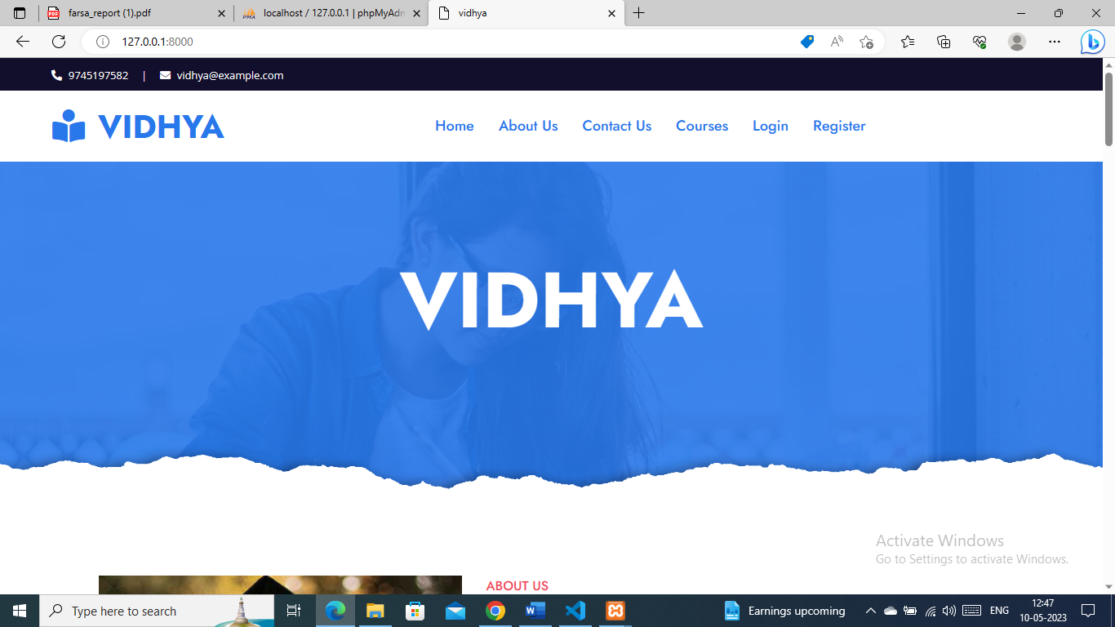

**ABOUT US**



**CONTACT-US**

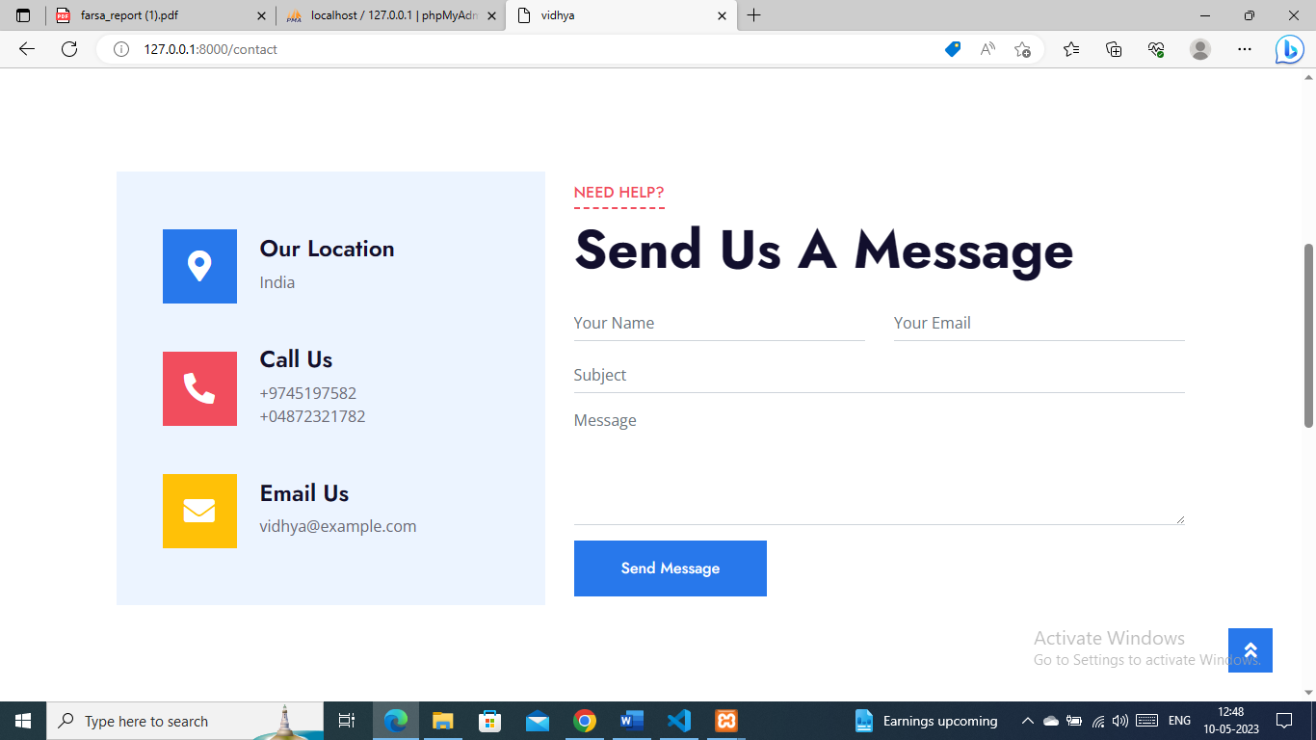

**STUDENT-REGISTRATION**

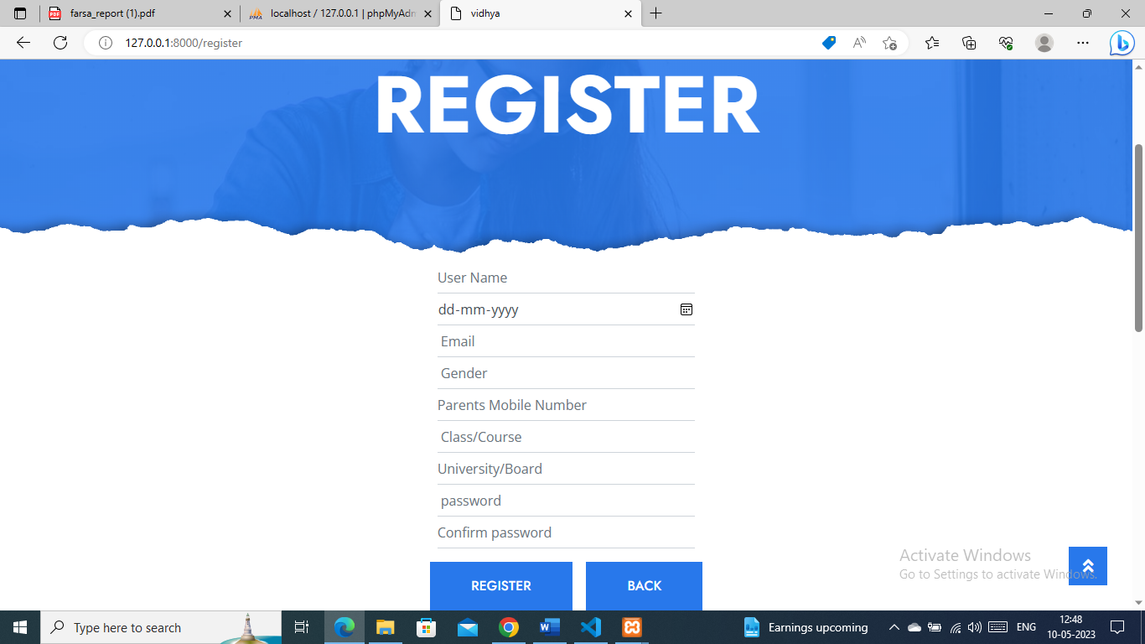

**LOGIN**

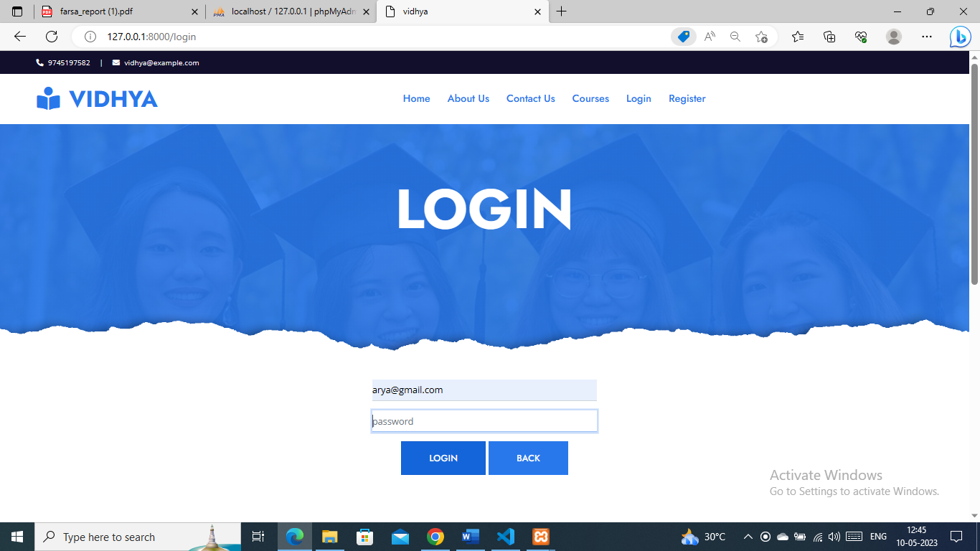

**ADMIN PAGE**

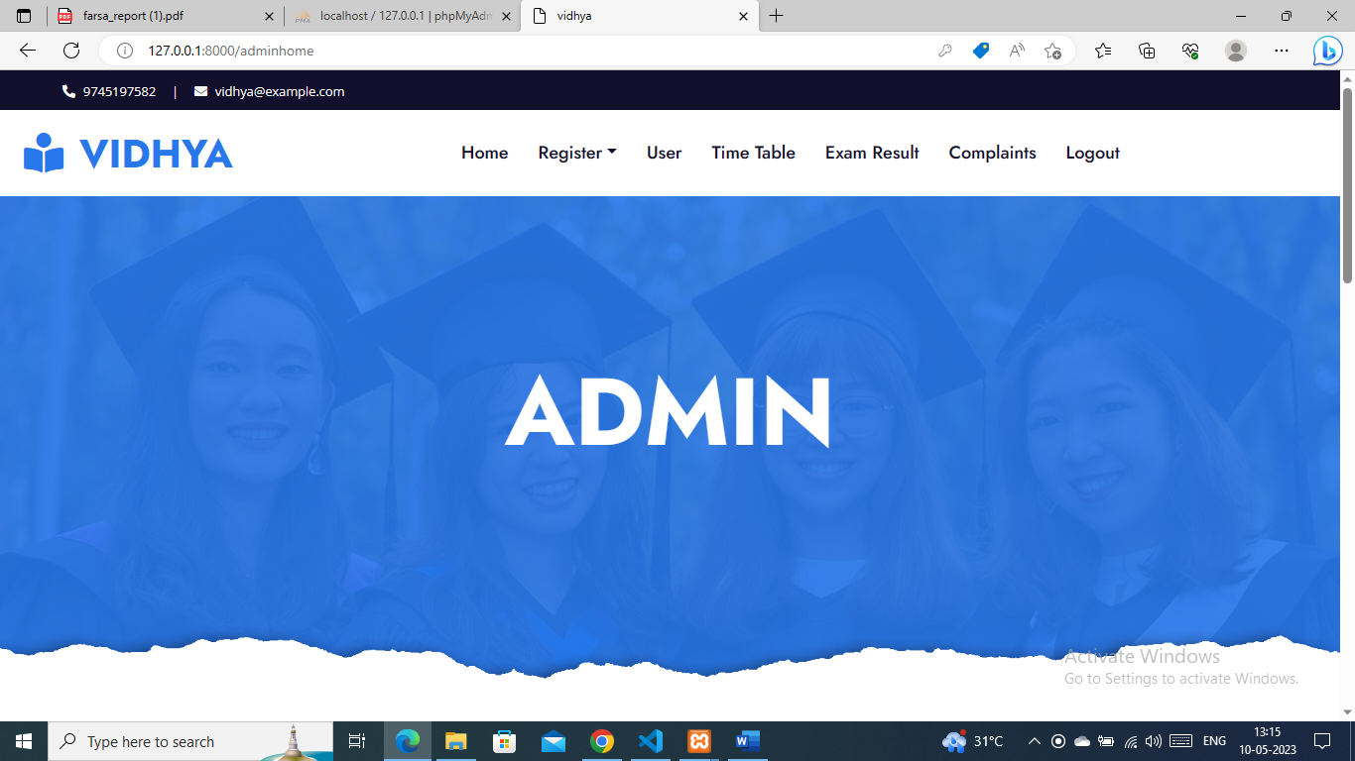

**APPENDIX B: TABLE DESIGN**

This project use tables are:

* Registration
* User type
* Complaint Registration
* Apply for job
* Upload question papers, question banks
* Video tutorials
* Google meet
* Add course
* Exam time table
* Add job offers

**DATABASE TABLES**

**TABLE 1 – REGISTRATION**

|  |  |  |  |
| --- | --- | --- | --- |
| FIELD | DATATYPE | CONSTRAINTS | DESCRIPTION |
| Reg_Id | Integer (10) | Primary key | Registration id |
| Name | Varchar (50) | Not null | name of the user |
| Age | Integer (50) | Not null | age of the user |
| DOB | Integer (50) | Not null | dob of the user |
| Course | Varchar (50) | Not null | Course of the user |
| University/Board | Varchar (50) | Not null | University/Board of User |
| Contact Number | Integer (50) | Not null | Contact Number of User |
| Email | Varchar (50) | Not null | Email of user |
| Password | Varchar (50) | Not null | Password of User |

**TABLE 2 – USER TYPE**

|  |  |  |  |
| --- | --- | --- | --- |
| FIELD | DATATYPE | CONSTRAINTS | DESCRIPTION |
| Id | Integer (10) | Primary key | User id |
| Reg_id | Integer (10) | Foreign key | Registration id |
| User type | Integer (10) | Not null | Type of user |

**TABLE 3 – COMPLAINT REGISTRATION**

|  |  |  |  |
| --- | --- | --- | --- |
| FIELD | DATATYPE | CONSTRAINTS | DESCRIPTION |
| cmp_id | Integer (10) | Primary key | Register complaints |
| Reg_id | Integer(10) | Foreign key | User details |
| Complaint against | Varchar (50) | Not null | Complaint against |
| Response | Varchar (50) | Not null | Responded by |
| Complaint description | Varchar (50) | Not null | Complaint description |

**TABLE 4 – APPLY FOR JOB**

|  |  |  |  |
| --- | --- | --- | --- |
| FIELD | DATATYPE | CONSTRAINTS | DESCRIPTION |
| job_id | Integer (10) | Primary key | Job applications |
| Reg_id | Varchar (50) | Foreign key | User details |
| Experience | Varchar (50) | Not null | Job experience |

**TABLE 5 – FEE PAYMENT**

|  |  |  |  |
| --- | --- | --- | --- |
| FIELD | DATATYPE | CONSTRAINTS | DESCRIPTION |
| fee_id | Integer (10) | Primary key | Fee payment |
| Reg_id | Varchar (50) | Foreign key | Registration id |
| Payment | Varchar (50) | Not null | Payment type |
| Amount | Varchar (500) | Not null | Total amount |
| Date | Integer (10) | Not null | Date of payment |

**TABLE 6 – UPLOAD QUESTION PAPERS AND QUESTION BANKS (Teacher)**

|  |  |  |  |
| --- | --- | --- | --- |
| FIELD | DATATYPE | CONSTRAINTS | DESCRIPTION |
| pb_Id | Integer (10) | Primary key | Upload files id |
| crs_id | Integer (10) | Foreign key | Course id |
| Subject | Varchar (50) | Not null | Subject |
| Upload file | Varchar (50) | Not null | Upload files |
| Year | Integer (50) | Not null | Year of question bank, question paper |

**TABLE 7 - VIDEO CLASSES**

|  |  |  |  |
| --- | --- | --- | --- |
| **field** | **data type** | **Constraints** | **Description** |
| vd_id | integer (10) | Primary key | video class id |
| Vd link | Varchar (100) | Not null | Link for video classes |
| Reg_id | Varchar (50) | Foreign key | User details |
| Course | Varchar (100) | Not null | Course of student |

**TABLE 8 – GOOGLE MEET**

|  |  |  |  |
| --- | --- | --- | --- |
| **field** | **data type** | **Constraints** | **Description** |
| gm_id | integer (10) | Primary key | Google meet id |
| Reg_id | Varchar (50) | Foreign key | User details |
| Vd link | Varchar (100) | Not null | Link for google meet |
| Course | Varchar (100) | Not null | Course of student |

**TABLE 9 – COURSE**

|  |  |  |  |
| --- | --- | --- | --- |
| **field** | **Data type** | **Constraints** | **description** |
| crs_id | Integer (10) | Primary key | Course id |
| Course name | Varchar (50) | Not null | Name of the course |

**TABLE 10 – SUBJECT**

|  |  |  |  |
| --- | --- | --- | --- |
| **field** | **Data type** | **Constraints** | **description** |
| sub_id | Integer (10) | Primary key | Subject id |
| Crs_id | Integer (10) | Foreign key | Course id |
| Subject name | Varchar (50) | Not null | Name of the subject |

**TABLE 11 - EXAM TIME TABLE** (**Examiner)**

|  |  |  |  |
| --- | --- | --- | --- |
| **field** | **data type** | **Constraints** | **description** |
| tt_id | integer (10) | Primary key | Exam Time table id |
| sub_id | Integer (10) | Foreign key | Subject id |
| Exam name | Varchar (50) | Not null | Name of exam |
| Date | Integer (10) | Not null | Date of exam |
| Time | Integer (10) | Not null | Time of exam |
| Subject | Varchar (50) | Not null | Subject of exam |
| Course | Varchar (50) | Not null | Course of user |
| link | Varchar (50) | Not null | Link for exam |

**TABLE 12 – UPLOAD EXAM RESULT**

|  |  |  |  |
| --- | --- | --- | --- |
| **Field** | **Data type** | **Constraints** | **Description** |
| rs_id | integer (10) | Primary key | Exam result id |
| reg_id | Integer (10) | Foreign key | Registration id |
| tt_id | integer (10) | foreign key | Time table id |
| Mark got | Integer (10) | Not null | Total mark got |

**TABLE 13 – JOB OFFERS(Manager)**

|  |  |  |  |
| --- | --- | --- | --- |
| **Field** | **Data type** | **Constraints** | **Description** |
| job_id | integer (10) | Primary key | Job offers id |
| Reg_id | integer (10) | Foreign key | Registration id |
| Experience | Varchar (50) | Not null | experience |
| Job type | Varchar (50) | Not null | Job needed |

**DATA FLOW DIAGRAM(DFD)**

**DFD 0th Level**

Manager

Student

Admin

Examiner

Teacher er

Manager

Examiner

Login

Teacher

Student

**DFD 1st LEVEL**

**ADMIN**

Admin

Admin

database

database

**DFD 1st LEVEL**

**MANAGER**

Mike request

Manager

advertisements

Company informations

Manager

Complaint

Job offers

**DFD 1st LEVEL**

**EXAMINER**

Exam

Time table

Exam result

Examiner

**DFD 1st LEVEL**

**TEACHER**

Question papers, banks

Video class

Google meet

Teacher

**DFD 1st LEVEL**

**STUDENT**

Register

Question papers, banks

complaint

Video class

Student

payment

Apply for job

Google meet

**DFD 2nd LEVEL**

**ADMIN**

Registration

Complaint

payment

Exam result

Admin

Add/Update/Delete/

Show data

Logout account

**DFD 2nd LEVEL**

**MANAGER**

View

advertisements

Job application

Manager

View and respond

Add/edit/upload/show datas

Can logout

**DFD 2nd LEVEL**

**EXAMINER**

View

Examiner

Add/delete/edit

Exam result

Check answers

Can logout

**DFD 2nd LEVEL**

**TEACHER**

View

Online Google meet

Teacher

Tutorials

View

Upload, View, edit, add

Can logout

**DFD 2nd LEVEL**

**STUDENT**

register

Google meet

Complaint

Student

Download

Enter to exam

Videos

Can logout

**ACTIVITY DIAGRAM**

Login id & password

Examiner

Teacher

Student

Manager

Select Operations

View Operations

Exit

**CLASS DIAGRAM**

Login

Log ()

Student

Teacher

Examiner

Manager

Adminn

Log ()

Log ()

Log ()

Log ()

Log ()

Manager

Student

Teacher

Examiner

Admin

Update Update()

Update - Update ()

Update- Update ()

View-View ()

View-View ()

Insert –

Insert ()

Delete -Delete ()

Delete-

Delete ()

Delete -Delete ()

Registermanagerexamine

teacher

Insert –

Insert ()

Insert –

Insert ()

Insert -Insert ()

**APPENDIX C: CODE**